Brag sheet User’s Guide

Mason Palma

CISSP, A+, Sec+, CySA+, Pentest+

Brag sheet is a ‘bragsheet’ management software written in Java by Mason Palma. The intended purpose of this software is to assist sailors write their annual ‘bragsheets’ as the year progresses. The software uses its own file format to store persistent values associated with the user’s record. Please, ensure that you maintain the file-directory structure of the application as it is by default.

*File-directory structure of directory ‘\brag sheet’*

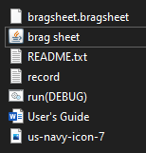

*Brag sheet*

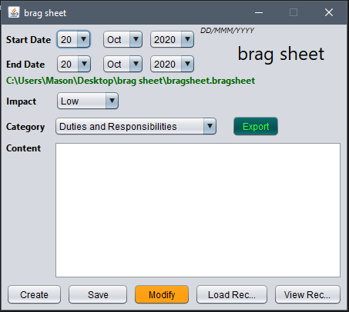

To launch brag sheet, double-click the ‘brag sheet.jar’ executable jar file or run the ‘run(DEBUG).bat’ file. Once launched, the user is presented with the main user interface. To make an entry, ensure the desired date, impact, category, and content are set as desired, then click the ‘create’ button.

*‘Create’ record entry*

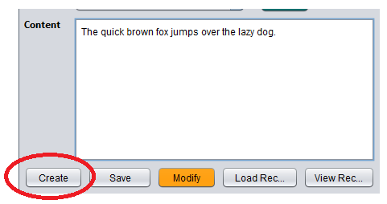

Once clicked, the content text area will be reset to an empty pane. The record can now be seen by clicking the ‘View Rec…’ button.

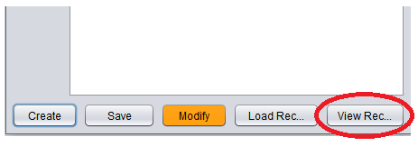

*“View Rec…”*

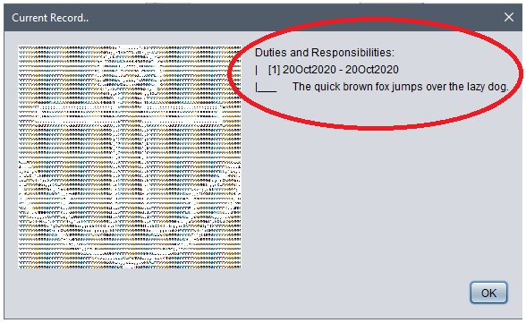

The records will be assorted by category, this pane should prove more useful with larger sized record files. A later update will provide the user with the ability to sort the record by impact, date, and category.

To save a record, click the save button. This will create a ‘bragsheet.bragsheet’ record in the ‘/brag sheet’ directory. This file will contain persistent values between instances. **Do not modify this file.**

*Save record*

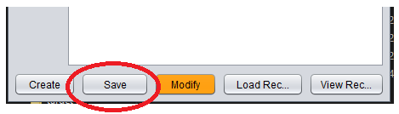

To modify a current record entry, select the orange “Modify” button.

*‘Modify’*

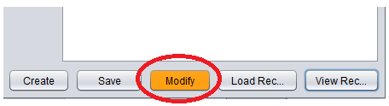

To view a record in the ‘Record Management’ pane, click its associated number under its category. Once selected, the record will appear in the empty text pane, on the right.

*‘Record Management’ pane*

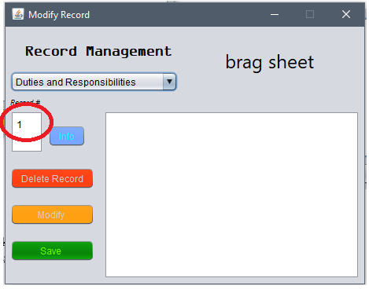

*Selected record*

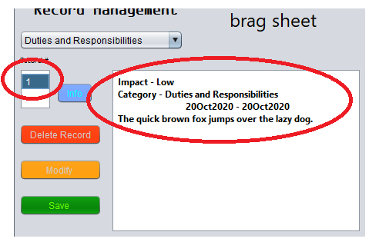

Once highlighted, you may make modifications to the record by clicking the ‘Modify’ button, which will open an “edit record” pane. To edit, make the modifications, then press the ‘Done’ button on the “edit record” pane. Lastly, press the “Save” button on the ‘Record Management’ pane.

*‘Modify’ button to ‘Edit Record’ pane*



*‘Edit Record’ pane*

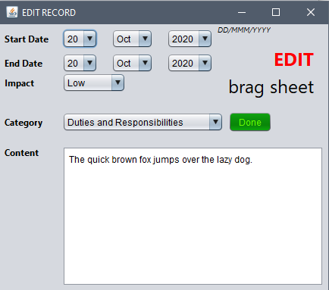

*Finish editing record entry.*

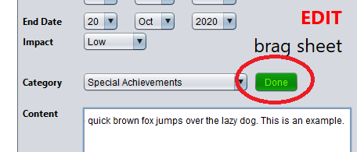

*Save after making modifications to update record.*

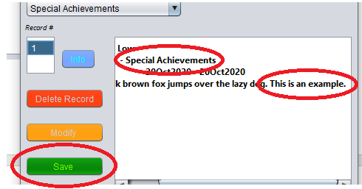

*Updated record entry*

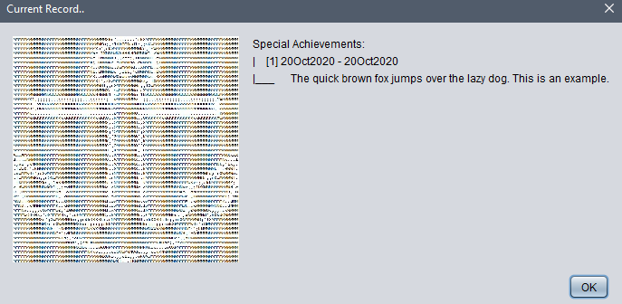

To export the current record, press the ‘Export’ button above the text are in the main user interface.

*‘Export’ button to export to txt file.*

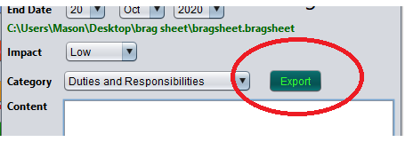

*Successful export pane with file’s location.*

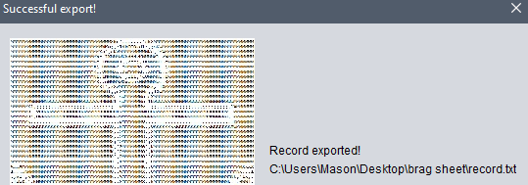

*‘Record.txt’*

